**Usability Tests**

-Xintong Wang

-1155130054

**Structure and Skeleton:**

**Site map**

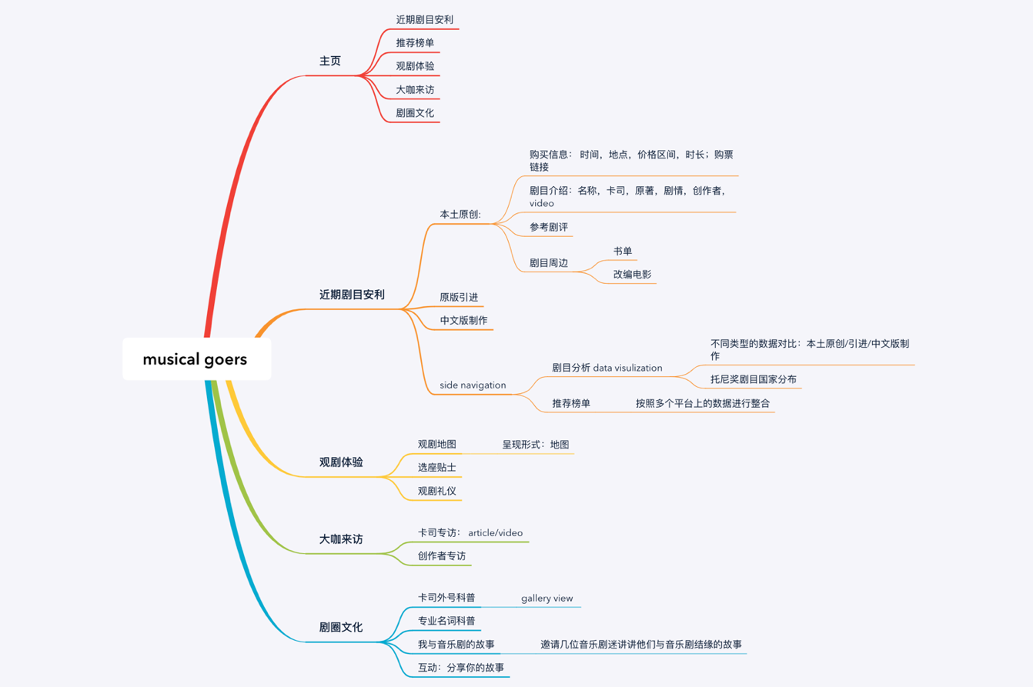

**Wireframes**

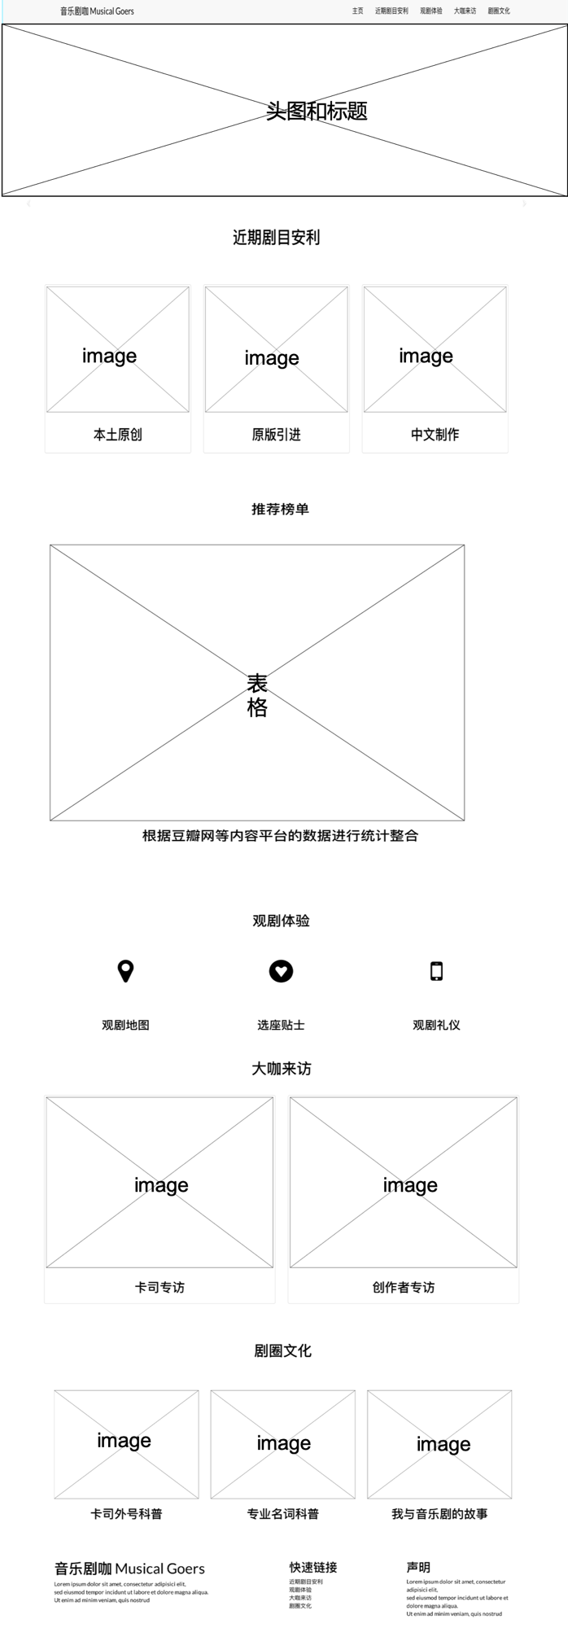

Figure1. home page

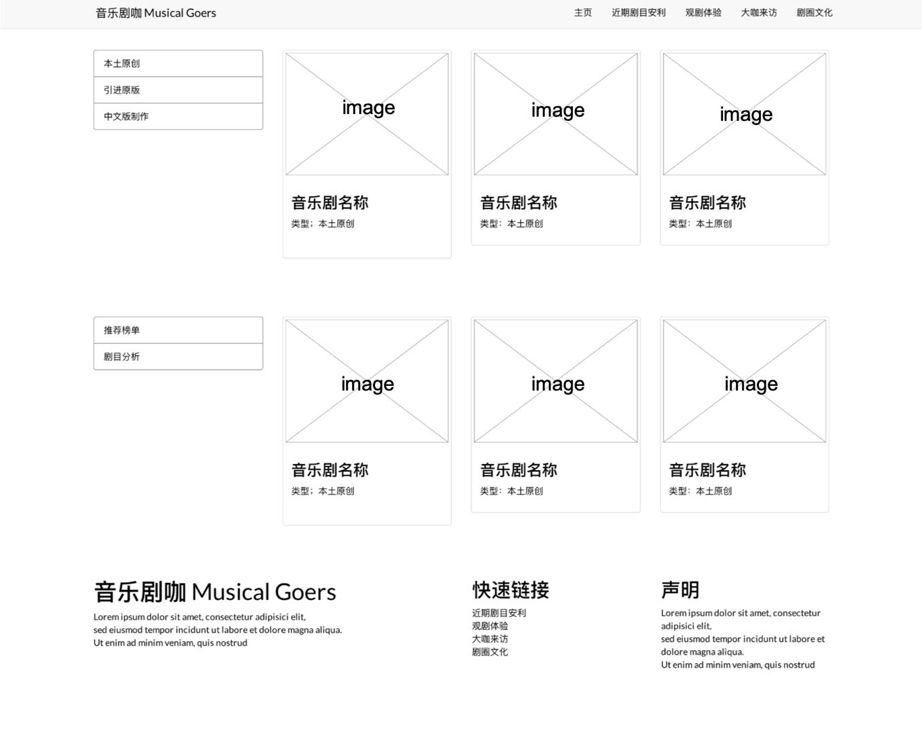

Figure2. page for “近期剧目安利”

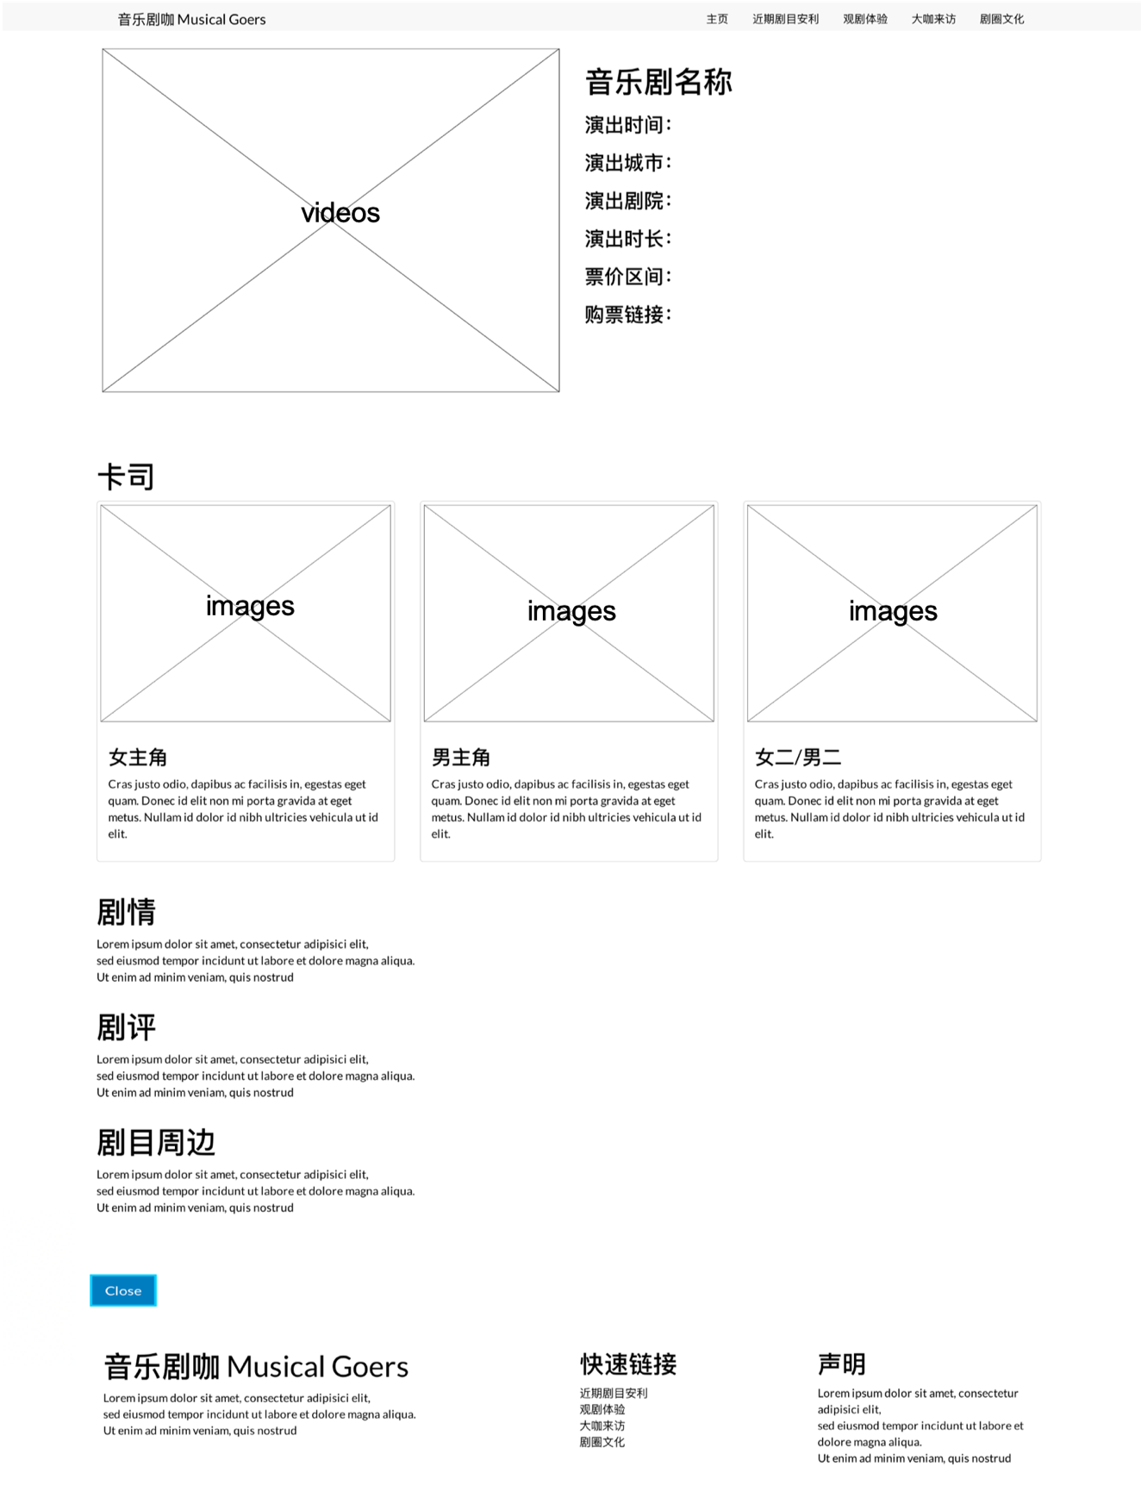

Figure3. page for detailed information of musicals

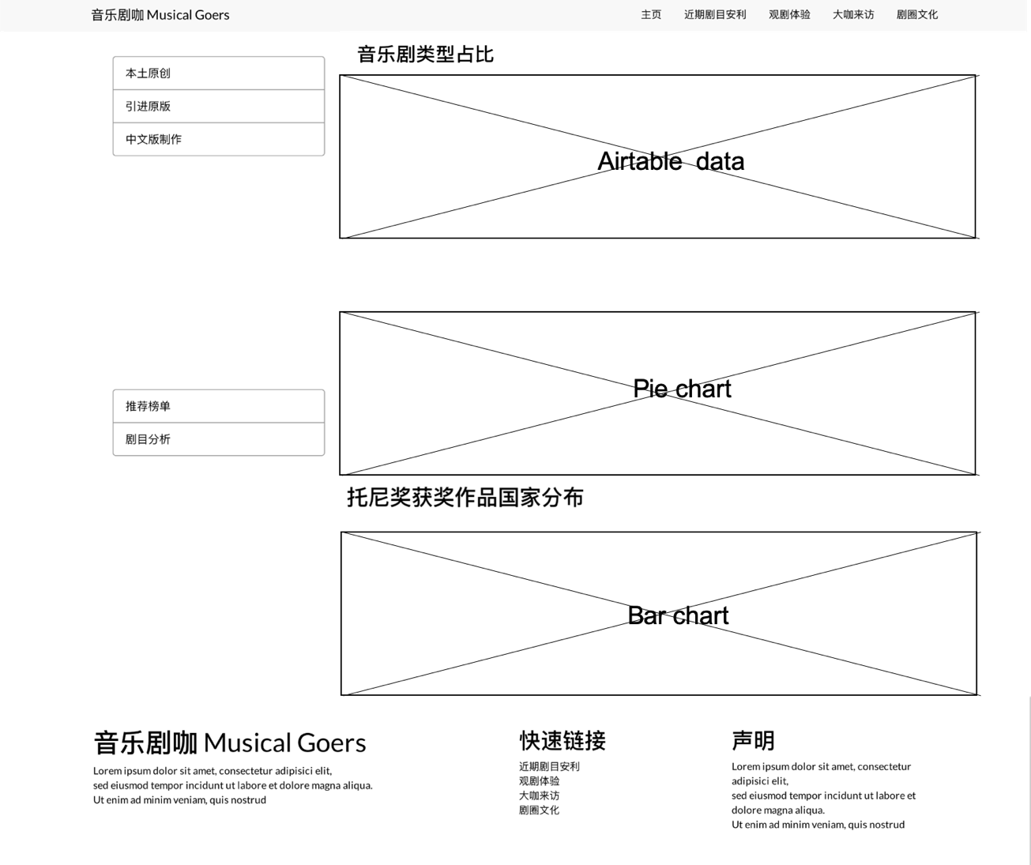

Figure4. page for musical analysis“剧目分析”

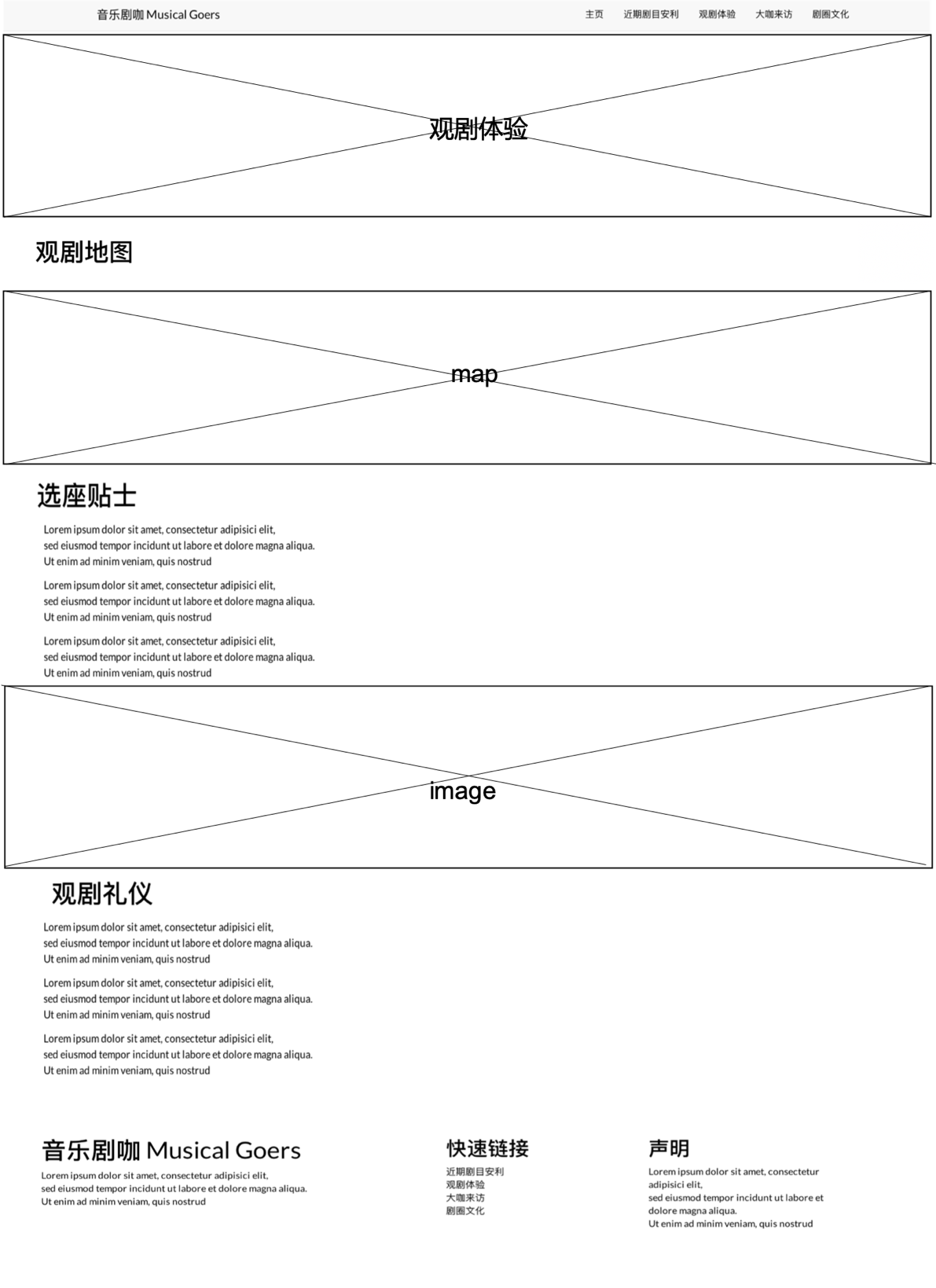

Figure5. page for guides for watching musicals “观剧体验”

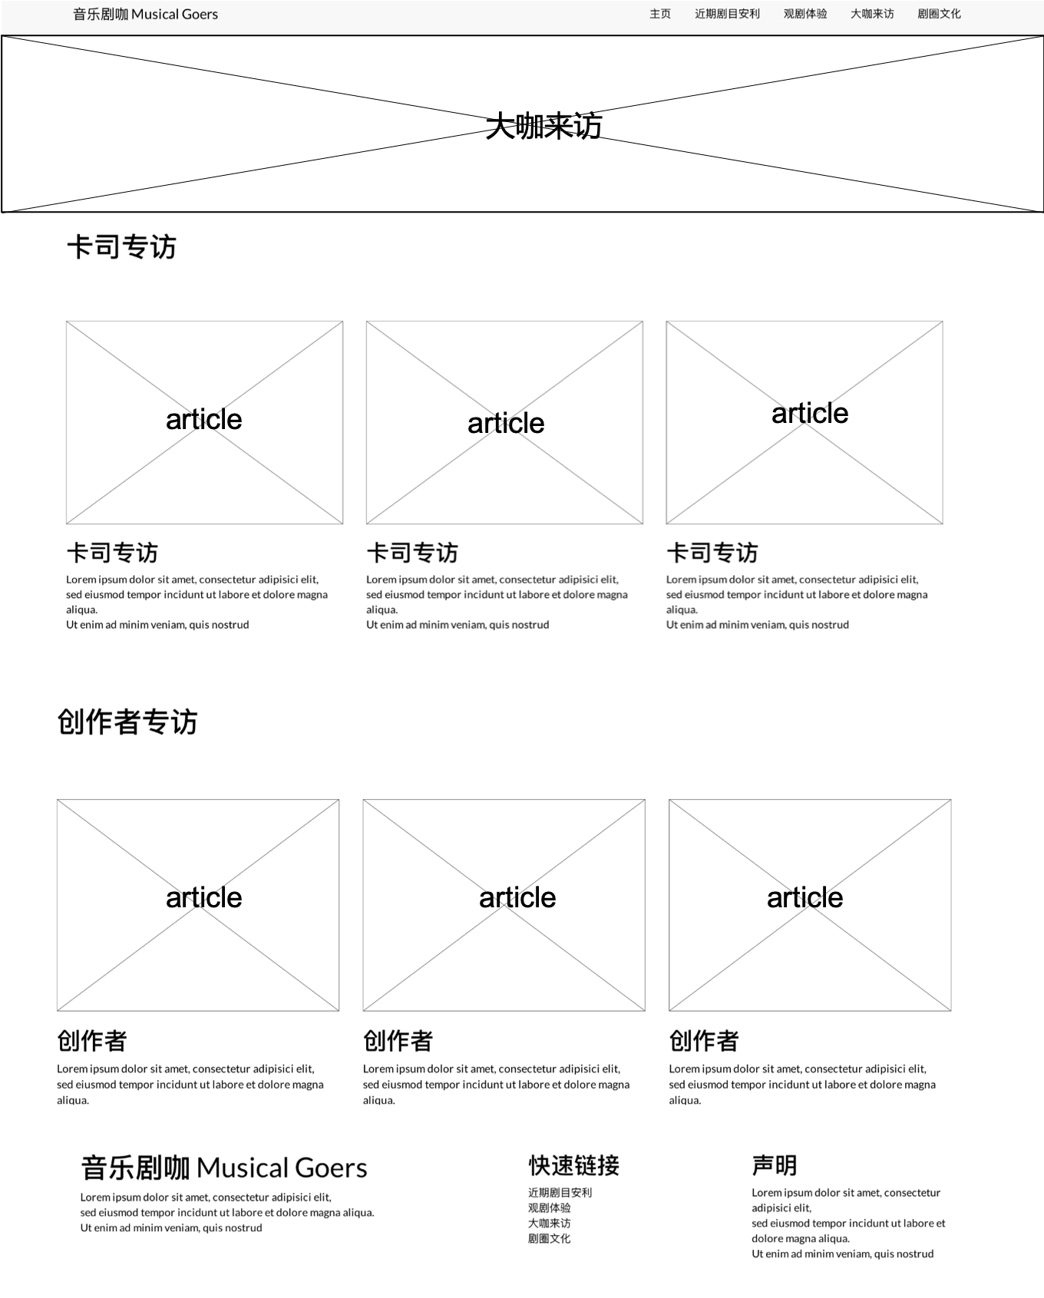

Figure6. page for interviews of practitioners “大咖来访”

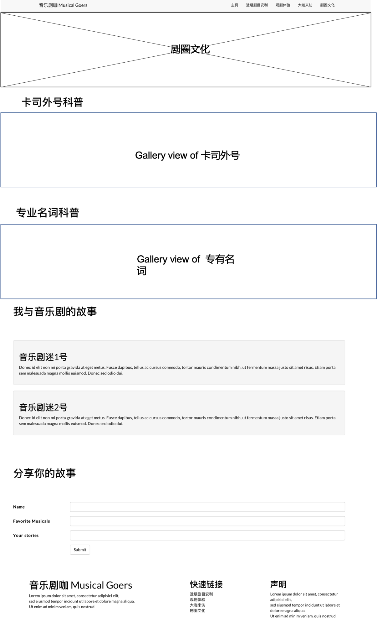

Figure7. page for musical culture “剧圈文化”

As the wireframes showcase, the musical goers website contains four sections, including musicals recommendations, guides for watching musicals, interviews of performers and creators as well as musical cultures. In order to evaluate the effectiveness of contents and layout, I conducted a usability test with five participants. Two of them are musical new commers that have little knowledge about the website but have great interest in this field, and the other three participants are musical loyal fans who have watched at least five musical performance and grasp a basic understanding of musical culture.

The problems five participants raised are quite helpful for me to further improve the user experience. I have concluded these problems in four categories and I also would like to come out with reasonable solutions. First of all, four of them have mentioned the contents on the home page. The two newcomers consider the classification and the subtitles quite confusing because they don’t know the different between “中文制作” and “原版引进”. And for the musical fans, they also think that the latest musical performance is not enough for them to digest and explore more various contents. Therefore, I think the contents for the first section need improvements. The classification will change to three parts “近期演出” without classification, “热门推荐” with data visualization to calculate the most popular and worth-recommending musicals and “经典音乐剧”.

The second problem refers to the main page for the musical performance (See Figure 2). Two participants find that the side navigation on the down left side is not clear. They are not sure that the lists targets whether all of the musicals or certain types of performance. And the link “剧目分析”is also quite ambiguous and less relevant to this page. Therefore, I will consider to delete “剧目分析” and put the popular musical lists in a single page.

The third problem is related to the detailed information page for musicals. As many musicals are performed in many cities in China for around half a year, so it is rather difficult to provide a concise information about the time, location, prices in a short answer. One of the musical fans thinks that it is always difficult to gather information of musical tours. Therefore, I plan to delete some detailed information for purchasing the tickets and provide a grid-view table “巡演信息表”containing detailed information of musical tours. I think it will be easier for people to find performance according to their location and time.

Additionally, two fans mention the musical culture section quite meaningful and creative, but they think the title should be further revised. It is not genuine to call “卡司外号科普” and “专有名词科普”. And one of the newcomers thinks that the name “观剧体验” is a little bit confusing. So I may change the names to “饭圈名词百科” , “相关术语科普”and “观剧指南” respectively.

**Usability testers’ profile**

As the website aims to target musical lovers and also promote the musical culture to wide public, it is important to choose five testers with different level of understanding. I invite one of my roommates and college classmate to join because both of them have little knowledge of musicals but show their great interests in this field. The roommate has once watched a musical performance in Shanghai but then have few opportunities to explore more. I also invite three musical fans. One of them have watched more than ten musical performance around the world, and she will also fly to foreign cities to watch a new musical show. Hence, she is a very senior fans of musicals and I am going to invite her to share stories on the website. The other two have averagely watched 4 musical performances in different cities in China but they may not have a thorough understanding of musical culture and they have keen needs for various musical information.

A revised vision of structure:

